Instruction for the 4th International and 29th National Iranian Food Science and Technology Congress

Title of your manuscript in English in 1 or 2 lines,
Single Space, Times New Roman 14pt, Bold
1cm

First name Last name¹, First name Last name^{2*}, First name Last name³ (Times New Roman 11pt, Bold)
¹Affiliation, name of department, University, city, country (Times New Roman 10pt, Bold)
²Affiliation, name of department, University, city, country (Times New Roman 10pt, Bold)
³Affiliation, name of department, University, city, country (Times New Roman 10pt, Bold)
*Corresponding Author’s E‐mail: ifsctc@gmail.com (Times New Roman 10pt, Bold)
Corresponding Author’s E‐mail: Insert Email Add. (Times New Roman 10 pt)
2cm

Abstract

All papers presented at 4nd International and 29th Iranian Congress on Food Science and Technology congress 2023 will be posted on Seminar Procedure Therefore; all papers written in Farsi should have their title abstract in English too. The abstract should a maximum of 250 words, written as a single paragraph, having 3.5 cm left and right margins. The abstract should be a self-contained, capsule description of the paper including the motivation, problem statement, approach taken, results and conclusions. Abstract should be prepared in 11 pt Times New Roman.
3.5 cm
3.5 cm

Keywords: Maximum 6 words separated by commas, Times New Roman 11 pt Bold.

2.5 CM
1. Introduction (11 pt, Bold, before 24 pt, after 12 pt)
The text must be in English. Spacing line: 1.1; font size: 11. All manuscript pages (including references, tables, figure legends, footnotes) must be 1.1-spaced and in a typeface of 11-point size. Authors whose English language is not their own are certainly requested to have their manuscripts checked (or co-authored) by an English native speaker, for linguistic correctness before submission and in its final version, if changes had been made to the initial version. The submitted typeset scripts of each contribution must be in their final form and of good appearance because they will be printed directly. The document you are reading is written in the format that should be used in your paper. This document is set in 11-point Times New Roman. If absolutely necessary, we suggest the use of condensed line spacing rather than smaller point sizes. Some technical formatting software print mathematical formulas in italic type, with subscripts and superscripts in a slightly smaller font size. This is acceptable.
2.5 cm
2.5 cm
Second line: before 6 pt, after 0 pt. In the introduction, you state the objectives of the work and provide an adequate background, avoiding a detailed literature survey or a summary of the results.

For single authors, cite as (name date) in text; citations are not numbered. For citations with two authors, cite as (surname and surname date). For citations with more than two authors, do not list all authors. Cite as (first author's surname et al. date) in text.

Manuscript-text must be saved as a MS Word file. Research papers must be no long longer than 5000 words, including abstract and references, but without tables, figures and the corresponding legends. Abstracts must not be longer than 200 words. You must include Keywords (≤ 5).
Page set up: paper size A4 (8.27” x 11.69”).
Margins: top & bottom: 1”; left & right: 0.6”.
First page margins: top 2”; bottom: 1”; left & right: 0.6”.
Paper submission in the repairable MS Word file and PDF file for reference (both types).

2. Materials and methods (11 pt, Bold, before 18 pt, after 12 pt)
Major headings are to be column centered in a bold font without underline. They need be numbered. "2.
Headings and Footnotes" at the top of this paragraph is a major heading.
2.1. Subheadings (11 pt, Italic, before and after 12 pt)
Divide your article into clearly defined and numbered sections. Subsections should be numbered 1.1 (then 1.1.1, 1.1.2, ...), 1.2, etc. Use this numbering also for internal cross-referencing: do not just refer to 'the text'. Any subsection may be given a brief heading. Each heading should appear on its own separate line.

3. Footnotes
Footnotes should be typed in singled-line spacing at the bottom of the page and column where it is cited.
Footnotes should be rare.

4. Results and discussion (11 pt, Bold, before 18 pt, after 12 pt)
4.1. Subheadings (11 pt, Italic, before and after 12 pt)
Results should be the major findings of your experiment. You have to compare the results with previous studies done in same.
5. Tables and figures
Number figures and tables consecutively in accordance with their appearance in the text. Ensure that each illustration and table has a caption. Keep text in the illustrations themselves to a minimum but explain all symbols and abbreviations used in the caption. If analytical data are reported, replicate analyses must have been carries out. Provide the experimental conditions, as far as they are necessary for understanding. The reader should not have to refer to the text in order to understand the tables.
Place footnotes to tables below the table body and indicate them with superscript lowercase letters. Avoid vertical rules. Be sparing in the use of tables and ensure that the data presented in tables do not duplicate results described elsewhere in the article.

Example of Table: center text
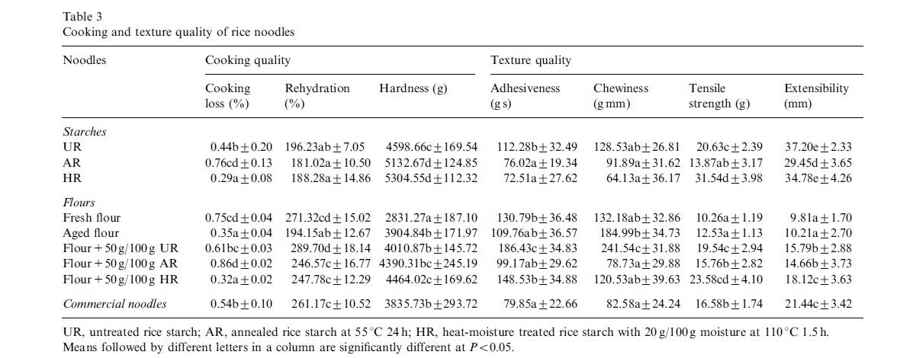

Example of Table: left or right text
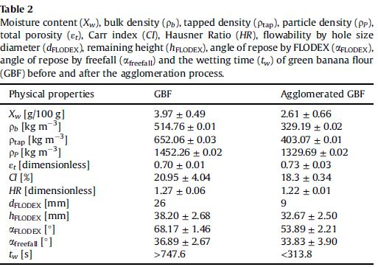

Example of Figure: center text
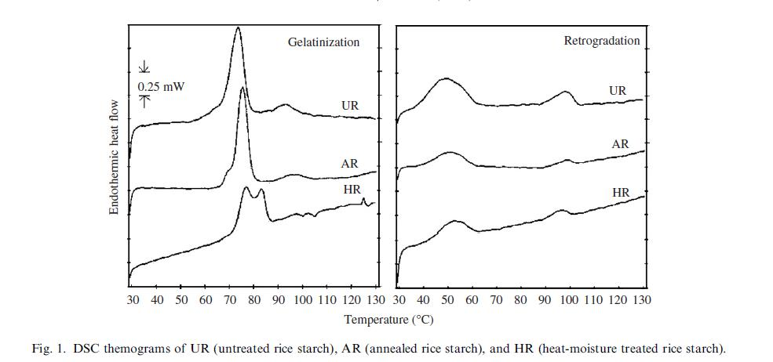

Example of Figure: left or right text
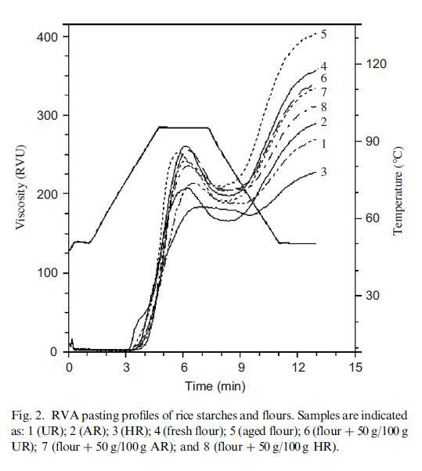

- Conclusions (11 pt, Bold, before 18 pt, after 12 pt) Here conclude your finding to with object of your studies.

- Appendix

Appendixes, if needed, appear before the acknowledgment.

8. Acknowledgments
Insert acknowledgment, if any. The preferred spelling of the word “acknowledgment” in American English is without an “e” after the “g.” Use the singular heading even if you have many acknowledgments. Avoid expressions such as “One of us (S.B.A.) would like to thank ... .” Instead, write “F. A. Author thanks ... .” Sponsor and financial support acknowledgments are also placed here.

9. Citation in text

Please ensure that every reference cited in the text is also present in the reference list.

All citations in the text should refer to:

  - Single author: the author's name (without initials, unless there is ambiguity) and the year of publication (Smith, 2003);

  - Two authors: both authors' names and the year of publication (Smith & Jones, 2004);

  - Three, four or more authors: all authors names and year of publication (Smith, Jones, & Brown, 2005). For all subsequent citations of this work use et al. (Smith et al., 2005).

- Reference (do not put number, 11 pt, Bold, before 18 pt, after 12 pt)
Van der Geer, J., Hanraads, J. A. J., & Lupton, R. A. (2010). The art of writing a scientific article. Journal of Scientific Communications, 163, 51–59. (Reference to a journal publication)

Strunk, W., Jr., & White, E. B. (2000). The elements of style. (4th ed.). New York: Longman, (Chapter 4). (Reference to a book)

Mettam, G. R., & Adams, L. B. (2009). How to prepare an electronic version of your article? In B. S. Jones, & R.

- Smith (Eds.), Introduction to the electronic age (pp. 281–304). New York: E-Publishing Inc. (Reference to a chapter in an edited book)

Cancer Research UK. Cancer statistics reports for the UK. (2003). http://www.cancerresearchuk.org/aboutcancer/statistics/cancerstatsreport/ Accessed 13.03.03. (Reference to a website)

